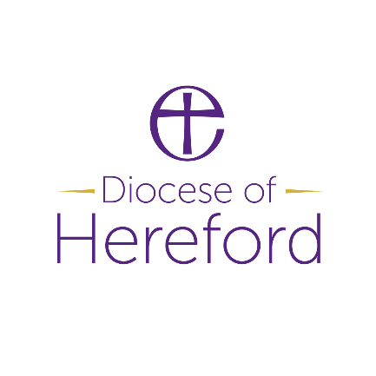

Youth Hub Co-ordinator

Dear Applicant,

Thank you for your interest in this role.

Hereford Diocese is committed to reaching, discipling and developing church with and for young people. We are motivated to enable local churches to support young people in their communities, bringing hope, support and Good News. As our Youth Hub Co-ordinator, you will be a key leader in enabling this vision and we would love you to join our growing and supportive diocese team.   
  
If you are passionate about youth work, intergenerational church and enabling new and emerging leaders to develop their calling, we would love to hear from you!

Your role will include:

* Working across rural areas, enabling local churches to work together and create a vision for youth ministry and then put it into practice!
* Connect enthusiastic local churches to our new Youth Hubs, supporting them to step out in faith and try new mission with young people together.
* Support and Line Manage our new Youth Pioneers, as they lead a local Youth Hub.

Our Youth Hubs are part of a big vision for growing youth ministry across our diocese and this role will include work with existing and emerging Youth Hub areas. You will be someone who can balance strategic thinking with actively walking alongside local churches on the ground, as they develop their youth ministry skills.   
  
As part of the team, you will gather stories and report on the development of the Youth Hubs, as part of a wider research programme that will enable us to grow our network of Youth Hubs and discern the future direction of rural youth ministry.

If you are excited about this opportunity and sense God is calling you to serve young people in rural Herefordshire and South Shropshire, we would love to hear from you and talk more!

For an informal discussion please contact Lizzie Hackney (Lead Intergenerational )

01432 373330